**Lab Session 0****9**

tooba.ali@nu.edu.pk

**Logical vs Arithmetic Shifts**

* A logical shift fills the newly created bit position with zero

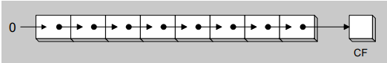

* An arithmetic shift fills the newly created bit position with a copy of the number’s sign bit.

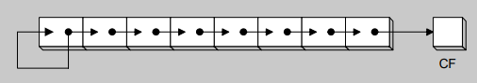

**SHL Instruction**

* The SHL (shift left) instruction performs a logical left shift on the destination operand, filling the lowest bit with 0.
* Shifting left 1 bit multiplies a number by 2

mov dl,5 ;CF=0, dl=00000101 (5)

shl dl,1 ;CF=0, dl=00001010 (10)

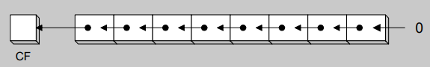

**SHR Instruction**

* The SHR (shift right) instruction performs a logical right shift on the destination operand.The highest bit position is filled with a zero.
* Shifting right divides the operand by 2

mov dl,10 ;CF=0, dl=00001010 (10)

shr dl,1 ;CF=0, dl=00000101 (5)

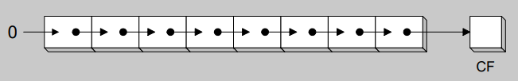

**SAL and SAR Instructions**

* SAL (shift arithmetic left) is identical to SHL
* SAR (shift arithmetic right) performs an arithmetic shift on the destination operand.
* Arithmetic shift preserves number’s sign.

mov dl,-80

sar dl,1 ; DL = -40

sar dl,2 ; DL = -10

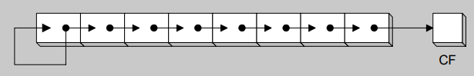

**ROL Instruction**

• ROL (rotate) shifts each bit to the left

• The highest bit is copied into both the Carry flag and into the lowest bit

• No bits are lost

mov al,11110000b

rol al,1 ;AL = 11100001b, CF=1

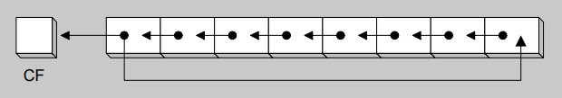

**ROR Instruction**

• ROR (rotate right) shifts each bit to the right

• The lowest bit is copied into both the Carry flag and into the highest bit

• No bits are lost

mov al,11110000b

ror al,1 ; AL = 01111000b, CF=0

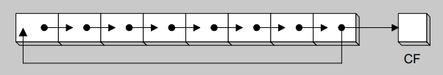

**RCL Instruction**

• RCL (rotate carry left) shifts each bit to the left

• Copies the Carry flag to the least significant bit

• Copies the most significant bit to the Carry flag

clc ; CF = 0

mov bl,88h ; CF=0 ,BL = 10001000b

rcl bl,1 ; CF=1 ,BL = 00010000b

rcl bl,1 ; ; CF=0 ,BL = 00100001b

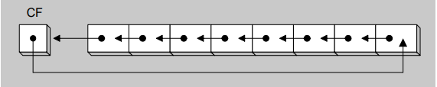

**RCR Instruction**

• RCR (rotate carry right) shifts each bit to the right

• Copies the Carry flag to the most significant bit

• Copies the least significant bit to the Carry flag

stc ; CF = 1

mov ah,10h ; CF=1 , AH = 00010000

rcr ah,1 ; CF=0 , AH = 10001000

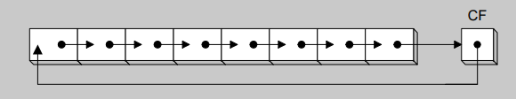

**SHLD Instruction**

• Shifts a destination operand a given number of bits to the left

• The bit positions opened up by the shift are filled by the most significant bits of the source operand

• The source operand is not affected

Syntax: SHLD destination, source, count

.data

wval WORD 9BA6h

.code

mov ax,0AC36h

shld wval,ax,4

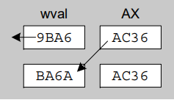

**SHRD Instruction**

• Shifts a destination operand a given number of bits to the right

• The bit positions opened up by the shift are filled by the least significant bits of the source operand

• The source operand is not affected

Syntax: SHRD destination, source, count

mov ax,234Bh

mov dx,7654h

shrd ax,dx,4

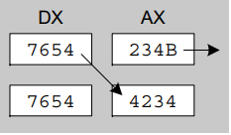

**ACTIVITIES:**

1. Run shift and rotate program and observe how contents of the register change. Write down result after each line of the code.
2. You need to build an encryption/decryption program using shift, rotate and arithmetic instructions of your choice. First, build a encryption process using at least 6 step instruction. Then build the decryption key to decrypt the encrypted number. You need to print the number before and after encryption and decryption operations.